Draft: FAQ on Local PV in Colorado. Commentary on topics that I often hear discussed.

R. A. Sinton
July 20, 2022

How are we doing with PV in Colorado?

How expensive is the Renewable Energy Standard Plan (RES Plan) in Colorado?

What are the fundamental reasons that distributed PV costs more?

Why does Minnesota have 800 MW of Community Solar while Colorado only has 83 MW?

Do Minnesotans get 100% clean power when they sign up for community solar in Minnesota?

Is it economical to do subscription community gardens?

Is community solar more cost-effective in Colorado than in Minnesota?

Does distributed PV help fight climate change in Colorado?

How are we doing with PV in Colorado?
Colorado had about 4% of its power generated by PV in 2021. In 2023, Xcel will have 15% of its power generated by PV (up from about 8% this year) and anticipates 25% PV by 2030. The rest of the state is on a similar track.
How did we get to this point?
Colorado established net metering quite early, leading to growth in residential PV systems. Net-metering allows the homeowner to send power to the grid when the PV is producing (during daytime) and pull power from the grid at night and on cloudy days. A customer’s bill is based on the difference between how much power is pulled from the grid compared to the power sent into it. If the PV array sends the same amount of power to the grid as it pulls from the grid, then the customer might just pay a low fixed fee and nothing for the electricity itself.
This essentially allows the homeowner to use the grid for electricity reliability but otherwise pay very little for it. Every KWH produced by the home PV array saves the homeowner about $0.12. This encouraged the early adoption of PV in Colorado when PV modules were expensive because the cost of the array could be paid off with savings in electricity per month. In addition, the investor-owned utilities offered up-front incentives to homeowners paid for by a 2% fee on all electricity customers (called the “RESA” on the electricity bill). This was mandated by the Renewable Energy Standard passed by a vote (Initiative 37 in 2004), and then the legislature through the years requiring 3% of the renewable energy to be distributed rather than utility-scale. Until 2016, there was more distributed PV than utility PV in Colorado according to EIA data.
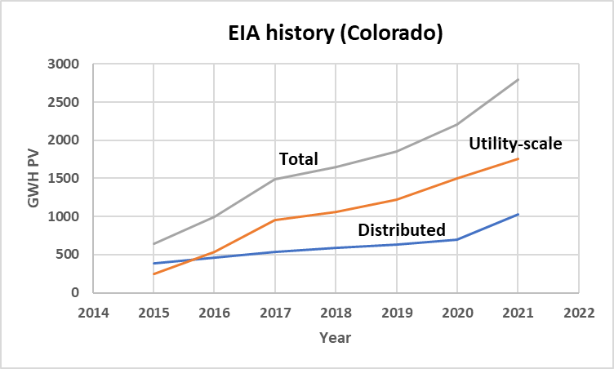
Fig. 1. The PV energy vs. year in Colorado.
In the 2016 Xcel resource plan, a competitive all-source bid indicated that utility-scale PV had become very cheap and available. This made utility-scale PV competitive with coal and gas at large scale. These power purchase agreements came in at about $0.031/KWH without batteries, and $0.038/KWH with batteries. As a result, the 2018 Colorado Energy Plan approved several large installations of PV for 2022, especially in the Pueblo area, in part to replace the Comanche 1 and Comanche 2 coal power plants as they retire. The trend is shown in Fig. 2, extended out as anticipated for the 2021 resource plan from Xcel. In this resource plan, the cost of utility-scale PV is expected to be 0.035/KWH including the cost of transmission.
The installation of about 1GW of utility-scale PV in 2022 changes everything to do with the value of PV to the grid. In addition to the ~40% of the electricity now supplied by wind, daytime can frequently be 100% renewable and accounts for 70% of power during daytime on average. In this case, additional PV does not replace as much coal and gas as it once did when we had a fossil grid. For planning purposes, distributed PV simply results in less utility-scale PV since we can only use so much PV during daytime. The two sources of PV trade off at this point, with distributed PV simply being more expensive (by about 2-4X). It is no longer worth $0.12/KWH to the grid at noon. Starting in 2023, residential rooftop users will be sending power to the grid when it could be supplied by utility-PV at $0.035/KWH and pulling power from the grid at all other times. All PV users will be pulling power from the grid at the same time (night and snowy days) increasing the price of power during those times. Rooftop PV will be using power from the grid during some the most expensive hours and providing PV in the hours when it is plentiful and cheap due to the combined effects of rooftop solar, community solar, and utility-scale PV all providing power during daytime hours in addition to daytime wind to meet demand.
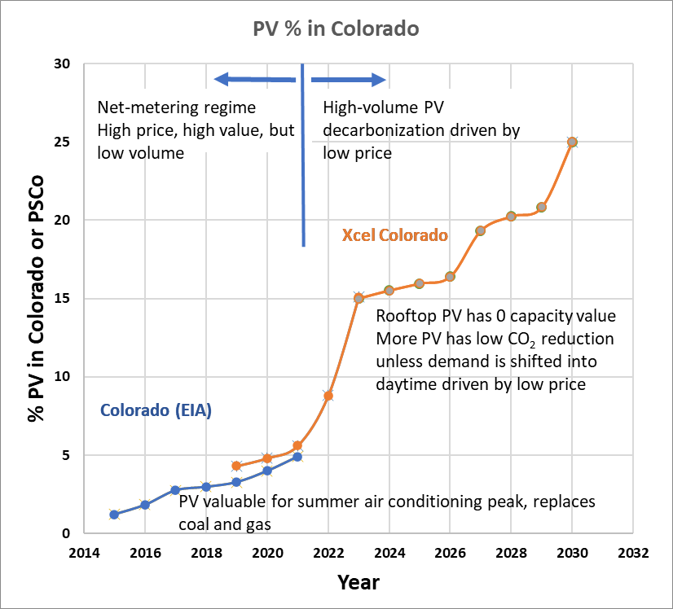
Fig. 2. The percentage of PV in Colorado vs. year historical and projected through 2030.
This is the opposite situation compared to 2014, when PV was be sent to the grid during the summer air-conditioning peak when power was expensive and taken from the grid during the fossil-fuel excess-capacity nights when power was cheap. Conventional thinking about net-metering was based on that period of time—when PV was just starting out-- and is obsolete now that PV can become a majority source of our electricity and has started to compete with itself during daytime hours to drive down prices.
Everything has changed. As a result, the justification for encouraging installation of rooftop PV by compensating power sent to the grid at retail prices no longer exists. The compensation needs to fall closer to the economic optimum (utility-scale PV + transmission costs) in order to maximize continued installation of rooftop PV without incurring a large effect on electricity rates. Scaling up the volume of distributed PV depends critically on lower installed prices and compensation.
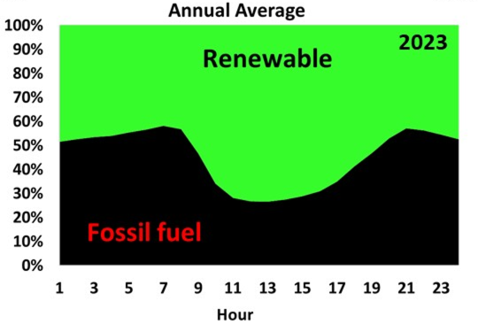
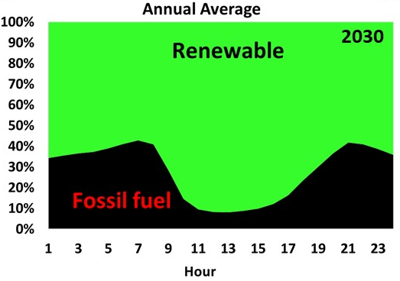
Fig. 3. The decreasing fraction of fossil fuel burned for the electricity supply in the Public Service Company of Colorado balancing area projected to 2030 based on 2019 historical data with the renewables scaled to the percentages shown in Fig. 2 (with similar data for wind, not shown in Fig. 2.)
Back to top

How expensive is the Renewable Energy Standard Plan in Colorado?
The renewable energy standard in Colorado is a mix of distributed programs such as rooftop PV, commercial PV, and community solar that are smaller than utility-scale projects.
The proposed RES plan in 2022 costs $3B and results in about 1GW of PV. This is 2.4X more expensive than the same amount of PV if it were installed as a PPA from an all-source bid including transmission costs. There are some arguments that the $3B price tag was not calculated correctly, (By COSSA, for example) but I believe that a careful calculation would result in something in the $2.4-$3B range as the arguments presented by COSSA are mostly obsolete because they were more relevant to the stage where very little PV was on the grid, utility PV was nearly as expensive as rooftop PV, and power from rooftop PV replaced mostly coal and gas during peak summer hours.
The renewable energy standard plan in Colorado, initiated in 2004, was an ambitious plan to get a start on installing renewables in Colorado when they were still quite expensive compared to the coal and gas generation that Colorado had at the time. This plan has been very successful. Renewables have advanced tremendously since that time—in the 2018 Colorado Energy Plan, it was found that renewables at utility scale could be less expensive than fossil fuel alternatives in many cases.
The RES plan currently specifies 30% renewable by 2020 for investor-owned utilities. We have easily met this due to the recent low prices of utility-scale wind and PV. The RES plan also has a “set-aside” for 3% of retail sales being provided by distributed PV. This has also been met by PSCO buying the renewable-energy certificates for rooftop and community solar PV. However, this means that rooftop owners that have sold these Renewable Energy Certificates, RECs, (usually without knowing although it is in the fine print) do not have cleaner power than anyone else. The RECS are used to meet the 30% renewable requirement, not add to it. Excess RECs over the 30% limit are sold to entities that need offsets to meet renewable goals. There are very little CO₂ savings from RES-plan PV for two reasons:
- Most will simply substitute for utility-scale PV PPAs to meet the daytime power needs
- If Xcel buys the RECs, the project simply allows more CO₂ elsewhere until Xcel retires the RECs.
The exception is net-metered PV without PSCo buying RECs, which accounts for a small (but growing) fraction of the distributed PV being installed currently. These projects should be additional to whatever is required for CO₂ reduction by law for the utility.
With these costs, it is clear that utility-scale PPAs have the potential to lower electricity rates, while under the RES plan, distributed solar will raise electricity rates due to the high fixed prices imposed by net-metering and the current subsidies for community solar projects.
Actual costs of distributed PV have been falling, but the RES plan fixes high prices as shown in the graph here where I compare the cost trends from NREL (residential, commercial, and utility-scale) to the prices projected by PSCO in the 2021 resource plan and then the 2022 RES plan.
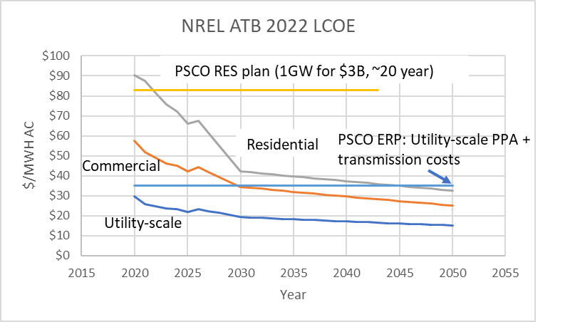
This high effective cost of PV could nullify PV’s main advantage in accelerating the clean-energy transition. By my calculations, the projected mix of distributed and utility PV in the ERP through 2030 will be installed at a blended cost of $0.06/KWH. The fossil fuel lobby could not dream of a better obstacle to adopting clean energy than doubling the price of installing PV on the system in order to raise the costs of clean energy and slow it down. It could also create a ratepayer’s backlash against rate increases and perpetuate the common “wisdom” that renewables are expensive.
The high prices for residential PV seem unique to the USA. In Poland and Spain, rooftop solar installs at a price less than 1 Euro/W (roughly 1$/W). In high-cost Germany, I am told that the price is ~$1.2-1.6/W. (I am looking for good citations to back this up). It seems likely to me that this could be due to the way that we subsidize rooftop PV. Net metering sets a very high price for PV to the utility that will be passed on to ratepayers. When the systems started to cost less than the net-metered compensation pays for, there was little incentive to innovate to cut cost below what is reimbursed in a short payback period by net metering. Additional to the ratepayers-provided subsidies, the federal investment tax credit, at 30% (although recently declining for residential PV) means that in effect, you “harvest” more federal money for higher-priced systems. This encourages gold-plated system designs with all of the extras in preference to cost-effective systems.
The city and state should work very hard on reducing costs (such as permitting, etc.), interconnect delays and costs, and expediting sales with education and consumer protections to reduce the barriers as a primary strategy to promote local solar. A recent DOE program was initiated to do this for community solar. Maintaining a net-metering price that is going up rather than down with time for PV contributes to high prices. Net metering has, in effect, meant that residential rooftop PV is defying the PV learning curve by staying at its ~2015 price, or increasing in price, while all-source bids have introduced competition such that utility-scale PPAs have followed the hardware cost curves down to very low prices. The resulting difference, $0.12/KWH (residential) vs. $0.025/KWH (utility PPA), prices residential rooftop out of the market for providing clean energy cost effectively even once transmission costs are accounted for.
Back to top

What are the fundamental reasons that distributed PV costs more?
Residential rooftop PV will always be significantly more expensive than utility-scale PV for several reasons. This will be the case as long as there is sufficient land for utility-scale projects and landowners will lease it for PV. In Colorado, all-source bids for utility-scale systems have resulted in many projects being offered.
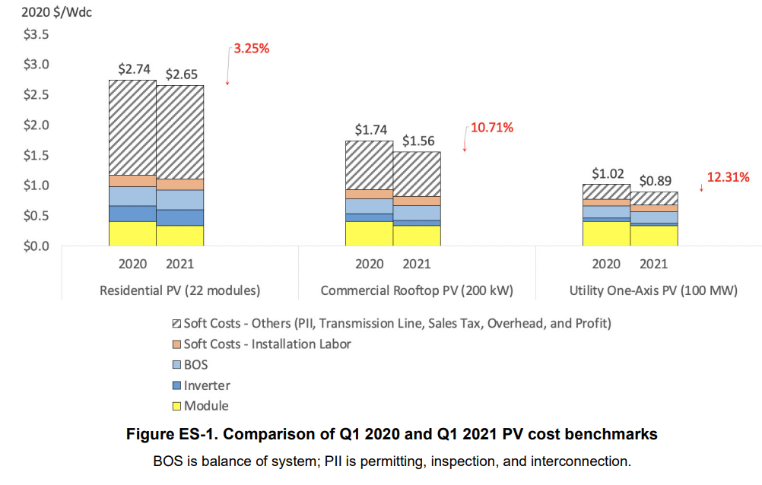
Figure from: Vignesh Ramasamy et al. U.S. Solar Photovoltaic System and Energy Storage Cost Benchmarks: Q1 2021, NREL/TP-7A40-80694, Nov. 2021

I would note that most utility-scale projects are now using bifacial modules that collect power from both the front and the backside of the arrays, while few rooftop systems can take advantage of this technology. When solar module costs were very high, before 2010, both utility-scale and rooftop systems were essentially determined mainly by the module costs and therefore both had similar costs. Currently, module cost is about 10% of the cost of a residential rooftop system. Lower module prices won’t help reduce the total cost much. Costs for both the residential and utility installations are higher in 2022 due to high demand for modules as well as supply chain and trade dispute issues.
In terms of hardware, residential PV costs about double what utility-scale costs, at about $1.0/W compared to utility-scale at $0.5/W in 2021. The inverters costs more, perhaps due to “microinverters” to deal with shadows as well as being smaller and less efficient. The biggest contributor to the extra total cost is the “soft costs” which include the cost of labor, project design, sales, and marketing for many small systems. Finally, systems such as residential rooftops will produce much less power (perhaps as much as 40% less) due to not tracking the sun, shadows, module orientation on the roof, and high operating temperature on rooftops. This could increase the price per KWH by 40% or more in comparison to the utility-scale systems using tracking.
Back to top

Why does Minnesota have 800 MW of Community Solar while Colorado only has 83 MW?
Discussions in Colorado concerning community solar often refer to all of the community solar installed in Minnesota. Therefore, it is instructive to look carefully at this case.
The ratepayers in Minnesota pay a very high price to subsidize this community solar, which shows up on their bills as a fuel cost adjustment. Minnesota has an uncapped Community Solar program that pays $0.1104 /KWH for a contract period of up to 25 years. This is attractive to developers (compared to building utility PPAs at ~$0.025/KWH) and explains why Minnesota installs a lot of community solar.
By my estimate, the costs for 800 MW of community PV would be:
2000 hours of PV per year * 25 years *$0.1104 * 800,000 KW = $4.416B. Each of 25 years, this would cost the ratepayers $177M/year, or $129M more per year than if they had installed the same 800MW of utility solar.
An equivalent 800MW utility-scale plant would cost approximately: 2000*25*0.03*800000 = $1.2B.
The ratepayers have paid ~$4.4B for ~$1.2B worth of solar. This is a premium of $3.6B paid to incentivize the installation of community solar in preference to utility PV. Each has the same environmental attributes in terms of CO₂/KWH reduction. In other words, the Minnesota ratepayers got 0.8 GW of PV for the price of about 2.9 GW of utility-scale PV. The local solar can have higher value in certain cases (if it saves costs in distribution and transmission, for example), but I don’t know of studies that would indicate that these savings are a very significant fraction of the $3.6B cost difference.
In the past, Colorado had a much more economical plan mostly involving competitive bids for the community solar that resulted in prices around the $0.07/KWH range. However, recently a community solar plant was approved with a cost of $0.117/KWH, with the increased costs attributed to a focus on marketing to low-and-middle-income households for the power.
These approximate calculations for the Minnesota Community Solar programs have been confirmed in a discovery response to a question by CRES, (CRES4-10) on Aug. 10 2021 in the ERP proceeding:
“DISCOVERY REQUEST CRES4-10:
With respect to CRES 1-1.A1, (Expanded Loads and Resources Table) , it appears there are 82.79 MW (nameplate) of Community Solar Gardens on PSCo’s system. According to the graphic below, Minnesota’s Community Solar Program has approximately 800 MW of Community Solar systems operating. Please explain why Minnesota has almost 10 times as many MW of Community Solar as PSCo has in Colorado.
https://ilsr.org/minnesotas-community-solar-program/

Response from Xcel:

The Minnesota Community Solar Program (“MN CSG”) operated by Xcel Energy affiliate Northern States Power Minnesota (“NSPM”) is an open program and has no capacity limits, while in Colorado the § 40-2-127, C.R.S. directs the Public Utilities Commission to set program limits for the CSG program. The MN CSG program also has a much higher bill credit rate and has seen substantially higher costs to customers, and costs more per kWh generated, than Colorado has achieved under its RFP-based program.
Under the MN CSG program as currently designed and operated, NSPM is required to purchase all the energy CSGs produced, at a pre-determined price – the “Value of Solar” rate - currently set at 11.04 cents/kWh, while the bill credit for Public Service CSGs is roughly 7 cents/kWh. The added cost flows directly to our customers through the fuel clause on their bills. These high costs are locked in for the duration of CSG developer contracts, typically 25 years. The cost impact on NSPM customers has become quite significant. Today, CSGs provide about 3% of all our energy but represent about 23% of the costs passed on to customers via the fuel clause. The annual premium – the difference between what energy from a CSG costs our customers, and what it would cost Xcel Energy’s customers if we acquired the same amount of energy from a utility-scale solar project – is today about $111 million overall, or about $32 per residential customer, including lower-income customers.

Sponsor: Jack W. Ihle Response Date: August 24, 2021”
Back to top

Do Minnesotans get 100% clean power when they sign up for community solar in Minnesota?

No. The utility buys the Renewable Energy Credits from the developer, which means that the utility can use these credits to comply with the clean energy portfolio. This simply allows the utility to install fewer renewables when it buys these credits. Otherwise, if the utility has already met the requirements, they can sell the RECs to someone else that wants to say that they are cleaner than their actual generation is. This community solar program doesn’t cut CO₂ because it does not retire the RECs. People signing up for community solar in Minnesota have the same carbon footprint as those that do not. They may be subscribing with the expectation that they are essentially buying 100% clean power. However, this is not the case.
Back to top

Is it economical to do subscription community gardens?
In Minnesota, it is about 4X more expensive than utility-scale PV. It can be more valuable if it is closer to the load or reduces distribution costs, but it definitely costs more. One of these costs is described below on the ILSR website which is the costs of reaching numerous subscribers and signing them up. Minnesota estimates this cost as $0.015/KWH, which it reimburses to the developer as described below.
“The Minnesota community solar program could better serve residential subscribers by carving out a portion of the overall program for them, providing resources for project development and technical assistance, or by compensating gardens that serve residential subscribers to offset the higher costs of reaching numerous subscribers.
The Minnesota Public Utilities Commission first introduced the Residential Adder in 2018. The adder boosted compensation rates for residential subscribers by 1.5 cents per kilowatt-hour for projects started in 2019 or 2020.”
Clearly, signing up a subset of ratepayers for community-solar-garden subscription adds cost compared to simply installing the same plant for use by all ratepayers by putting it on the existing grid and providing the clean energy to everyone. These same costs were cited as a reason why a recent community-solar project RFP in Colorado came in at very high prices ($0.117/KWH).
Back to top

Is community solar more cost-effective in Colorado than in Minnesota?
Yes. In the 2021 ERP, PSCO put the cost of community solar at $0.07/KWH, compared to Minnesota’s $0.1104/KWH. Elsewhere, as in the response to the discovery request from CRES, it has attributed this to the fact that many of these projects are competitively bid rather than being compensated at the high-fixed price of $0.1104 as in Minnesota.
Back to top

Does distributed PV help fight climate change?
It could, but in Colorado at present, distributed PV simply substitutes for utility-scale PV at a much higher price, with little or no additional CO₂ or environmental benefit. Since both sources of PV produce power at the same time, calculations for capacity value of PV now indicate that additional distributed PV has very little capacity value, since we will approach enough PV and wind (starting in 2023) to meet demand at noon on many days with the planned installations. Any distributed PV added to the system just reduces the amount of utility-scale PV installed in the resource plans, and increases the average price of PV. Customers interested in reducing CO₂ should sign up for “Windsource”, which retires RECS, or install rooftop PV under net-metering without selling the RECS to PSCO or anyone else.
The three strategies to expand distributed PV and address CO₂ could be:
- As storage comes down in price, install storage in the local distribution areas so that more PV produced at noon can be used during early evening without pushing it through the transmission lines when the lines approach peak capacity during late afternoon. Local PV and off-peak-hour utility PV and wind could charge these batteries.
- Lower the prices of local PV, by phasing down the compensation for power put onto the grid from the retail price (net metering) to the value of this power to the distribution grid. My Value of Solar calculations for Colorado, based on the Minnesota template, indicate that distributed PV should be compensated at about $0.04/KWH to be cost effective. We should find a glide path down towards this value from the current $0.12/KWH if we intend to cost-effectively install much distributed PV. This is the strategy used in the report “Why Local Solar For All Costs Less: A New Roadmap for the Lowest Cost Grid” by Vibrant Clean Energy (2021). At these reduced prices, it will make sense to install significant amounts of local PV. To reduce CO₂, the owner needs to retire the RECS rather than sell them off to the utility or a third party.
- Shift more existing demand into daytime and make sure that any new demand comes online mostly during daytime in order to be able to supply more of total demand with PV. This would allow more total PV on the system before reaching the “cap” where we meet existing daytime demand with PV and wind. In effect, this would enable PV to meet perhaps 40-50% of total demand, in contrast to the ~25% that PSCO essentially sets as a limit through their various assumptions.
Back to top

